# **ImagineAI Documentation**

Table of Contents

Introduction 1

Problem Background 1

1. Precision in Image Search: 1

2. Image Quality and Composition: 2

Proposed Solutions 2

1. AI-Powered Image Generation: 2

2. Image Enhancement Techniques: 2

Objectives 2

1. Image Generation: 2

2. Image Expansion: 2

3. Attention-Grabbing Enhancement: 2

4. Visual Composition Optimization: 2

5. Adaptability Across Platforms: 2

Scope 3

1. Artistic Generation and Design: 3

2. Educational and Creative Tools: 3

3. Research on Generative Models: 3

4. Safe Deployment: 3

Excluded Uses 3

Limitations 3

Methodology 3

1. Development Using Flutter Framework: 3

2. Integration of Deep Learning Model: 3

3. Diffusion-based Text-to-Image Generative Model: 3

4. Testing and Evaluation: 3

Dataset Description 4

1. Text Prompts: 4

2. Paired Images: 4

3. Metadata: 4

4. Data Preprocessing: 4

Functional Requirements 4

1. User Authentication: 4

2. Text-to-Image Generation: 4

3. Image Enhancement: 4

4. Image Expansion: 4

5. Platform Compatibility: 4

Non-Functional Requirements 4

1. Performance: 4

2. Scalability: 4

3. Security: 4

4. Usability: 5

Quality Attributes 5

1. Reliability: 5

2. Maintainability: 5

3. Portability: 5

4. Interoperability: 5

Entity-Relationship Diagram (ERD) 5

Use Case Diagram 5

Sequence Diagram 5

Activity Diagram 5

Summary 5

# Introduction

ImagineAI is an innovative application that leverages AI capabilities across Android, web, and desktop platforms. By utilizing advanced deep learning algorithms, ImagineAI converts text inputs into striking visual compositions, empowering users to generate captivating images effortlessly from simple text prompts, expand existing images, or create entirely new ones. Users can explore limitless creative possibilities with ImagineAI, whether on their Android device, web browser, or desktop.

# Problem Background

## Precision in Image Search:

* + Traditional image search engines often struggle to provide precise results based on specific textual prompts. They rely on keyword matching and metadata, which may not capture the nuanced context or desired elements of an image. This can lead to user frustration and inefficiency in finding visuals that accurately reflect their needs or preferences.

## Image Quality and Composition:

* + Images obtained through search engines or user-generated content platforms may suffer from deficiencies in quality or composition, impacting their suitability for professional or commercial use. Factors such as poor lighting, improper framing, or low resolution can detract from the overall appeal and usability of an image.

# Proposed Solutions

## AI-Powered Image Generation:

* + Utilizing AI algorithms to generate images based on specific textual prompts provided by users. This approach circumvents the limitations of traditional keyword-based search methods, offering users a precise and tailored visual experience.

## Image Enhancement Techniques:

* + Employing advanced image enhancement techniques to correct common imperfections such as exposure discrepancies, noise reduction, and geometric distortions. This ensures high-quality visuals that meet professional standards, regardless of the original capture conditions.

# Objectives

## Image Generation:

* + Develop capabilities for generating high-quality images based on specific textual prompts, leveraging AI algorithms to accurately interpret and represent the given descriptions.
  + Ensure the generated images are diverse, creative, and aligned with the user's input.

## Image Expansion:

* + Enhance existing digital images through strategic image expansion techniques to improve subject centrality and attention-grabbing qualities.

## Attention-Grabbing Enhancement:

* + De-emphasize distracting background elements to direct focus towards the subject.

## Visual Composition Optimization:

* + Adhere to visual composition guidelines such as the rule of thirds and leading lines.

## Adaptability Across Platforms:

* + Develop image generation and expansion techniques adaptable to various digital platforms and applications.

# Scope

## Artistic Generation and Design:

* + Generating artworks and exploring their application in design and other creative processes.

## Educational and Creative Tools:

* + Developing educational tools that utilize AI-generated images to facilitate learning and creativity.

## Research on Generative Models:

* + Conducting research on the capabilities, limitations, and biases of generative models.

## Safe Deployment:

* + Ensuring the safe deployment of generative models to prevent the generation of harmful content.

# Excluded Uses

* The project does not aim to produce factual or true representations of people or events.

# Limitations

1. The platform may not achieve perfect photorealism in generated images.
2. Generating legible text may pose a challenge.
3. Complex compositional tasks, such as rendering specific scenes or objects, may be challenging.
4. Faces and human figures may not be accurately generated.
5. The auto-encoding part of the platform may result in loss in image compression.

# Methodology

## Development Using Flutter Framework:

* + Utilize the Flutter framework for cross-platform compatibility and a consistent user experience across Android, web, and desktop platforms.

## Integration of Deep Learning Model:

* + Integrate a pre-trained deep learning model to power the core image generation functionality.

## Diffusion-based Text-to-Image Generative Model:

* + Employ a diffusion-based text-to-image generative model to generate and modify images based on text prompts.

## Testing and Evaluation:

* + Conduct thorough testing to ensure functionality, usability, and performance across different platforms.

# Dataset Description

## Text Prompts:

* + The dataset includes diverse textual descriptions or prompts for image generation and expansion processes.

## Paired Images:

* + Each text prompt is associated with one or more corresponding images generated or expanded based on the provided description.

## Metadata:

* + The dataset may include additional metadata such as image labels, annotations, or categorizations.

## Data Preprocessing:

* + The dataset undergoes preprocessing steps to ensure data consistency, quality, and compatibility with the deep learning models.

# Functional Requirements

## User Authentication:

* + Users must be able to create accounts and log in securely.

## Text-to-Image Generation:

* + Users can input text prompts to generate images.

## Image Enhancement:

* + Users can enhance existing images by improving quality and composition.

## Image Expansion:

* + Users can expand images to improve subject centrality and focus.

## Platform Compatibility:

* + The application must function seamlessly across Android, web, and desktop platforms.

# Non-Functional Requirements

## Performance:

* + The application should load quickly and process image generation and enhancement tasks efficiently.

## Scalability:

* + The system should be able to handle an increasing number of users and data without performance degradation.

## Security:

* + Ensure the security of user data and prevent unauthorized access.

## Usability:

* + The application should have an intuitive and user-friendly interface.

# Quality Attributes

## Reliability:

* + The application should function reliably without crashes or errors.

## Maintainability:

* + The codebase should be maintainable and well-documented to facilitate updates and bug fixes.

## Portability:

* + The application should be portable across different operating systems and devices.

## Interoperability:

* + The application should be able to integrate with other systems and platforms if needed.

# Entity-Relationship Diagram (ERD)

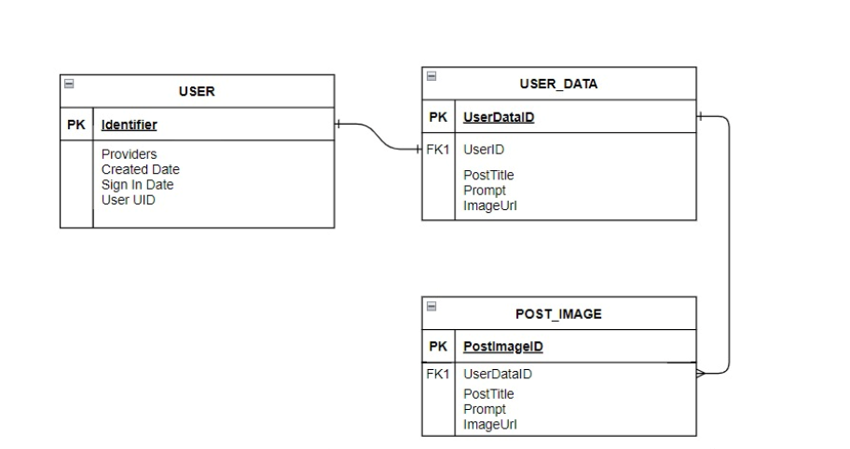

Use Case Diagram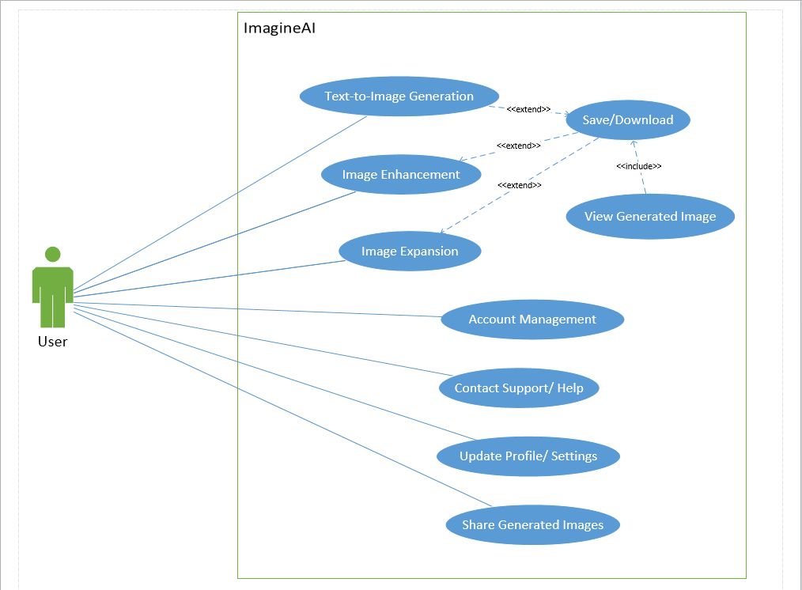

# Sequence Diagram

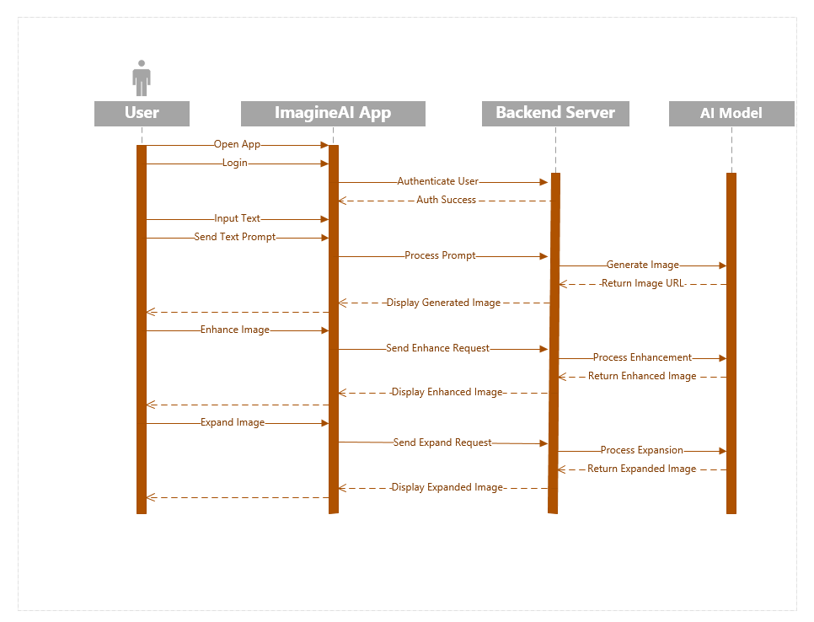

# Activity Diagram

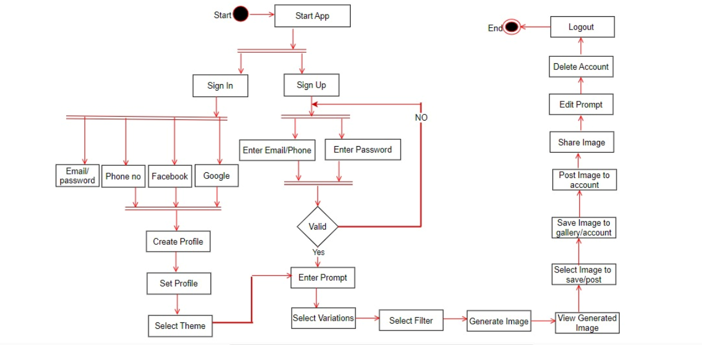

# Summary

ImagineAI is designed to revolutionize how users create and enhance images using AI. Through precise image generation, enhancement, and expansion, the application addresses common issues in image search and quality. The documentation outlines the project's functional and non-functional requirements, quality attributes, and detailed design diagrams to ensure a clear understanding of ImagineAI's development and operation.